**Assignment - 1**

**Objective:**

Create a simple Docker container for a web application.

1. Create a web application or use an existing one (don't use the project used in labs).

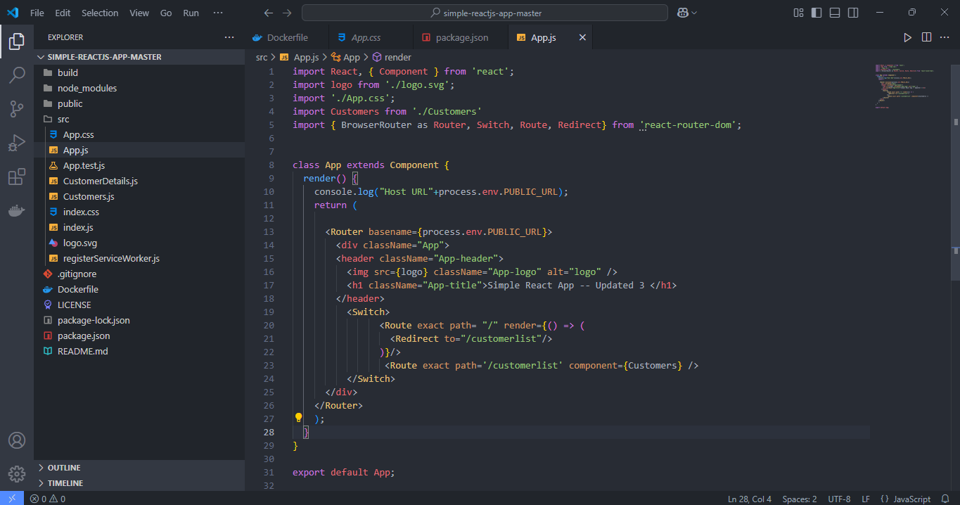

1. Write a Dockerfile (Multistage if possible) to containerize the application.

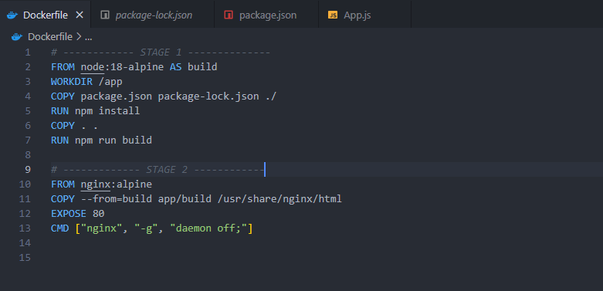

1. Build the Docker image, the smaller the size, the more marks you would get.

-> Build the docker image - react-webapp

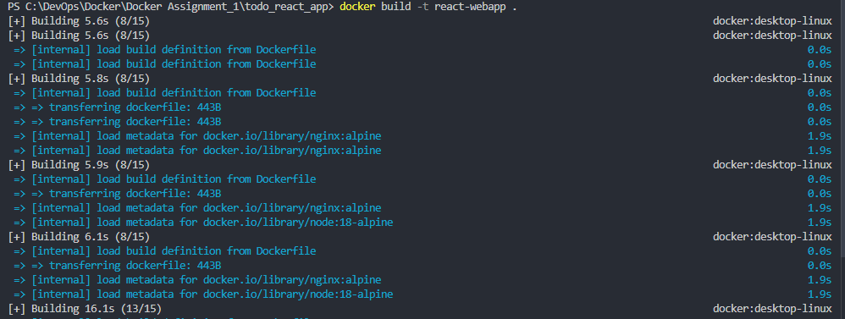

-> Check Image Size

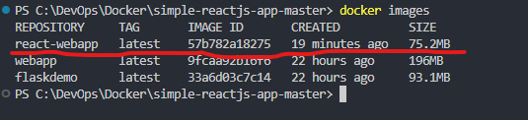

1. Push it to Docker hub, with at least 3 different tags.

-> Build image with tag 1

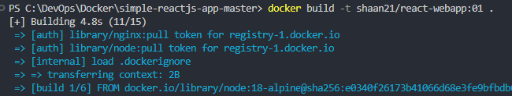

-> Build image with tag 2

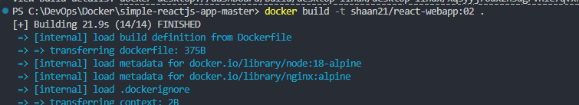

-> Build image with tag 3

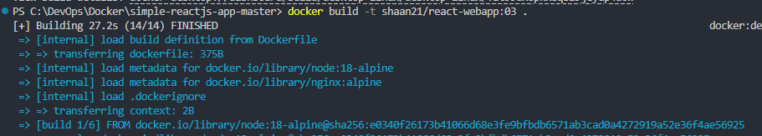

-> Push to docker hub

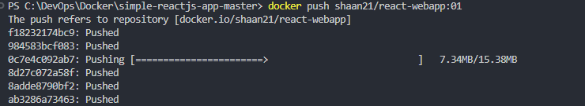

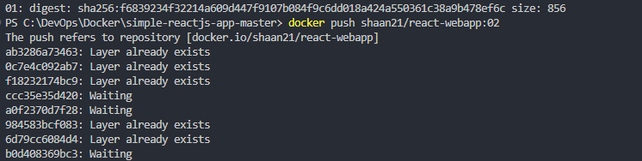

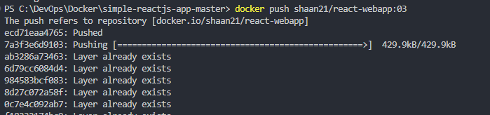

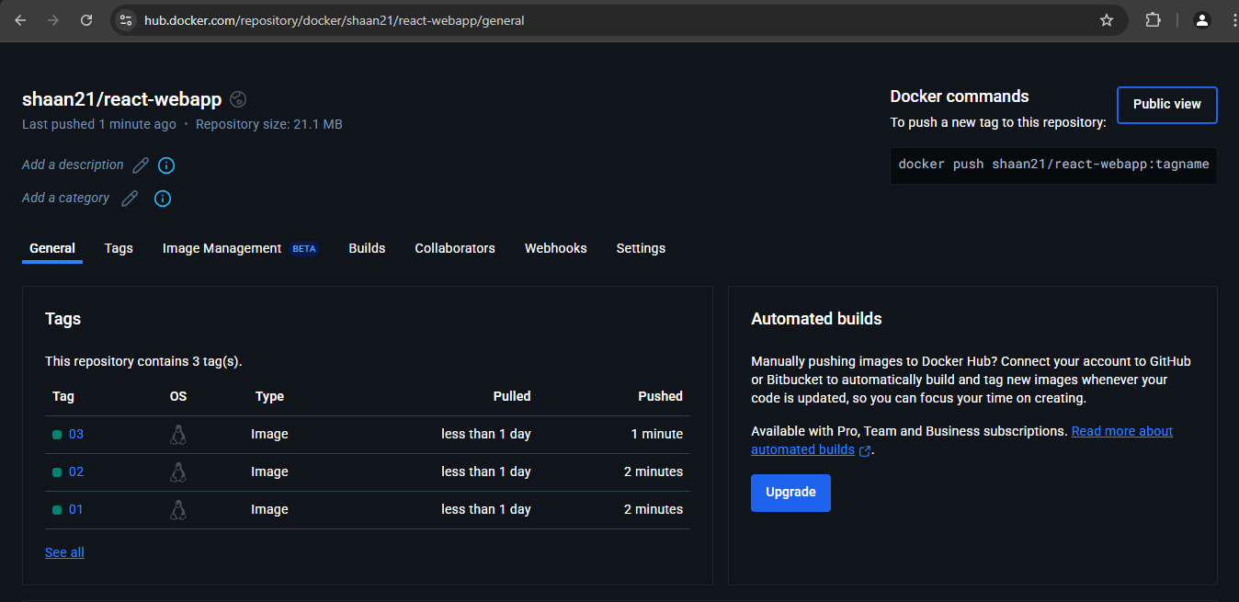

1. Run the Docker container from the image that you've built & access the web application in a web browser in local machine.

-> Run docker image to create docker container - react-webapp

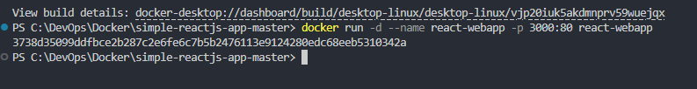

-> Open port: <http://localhost:3000/>

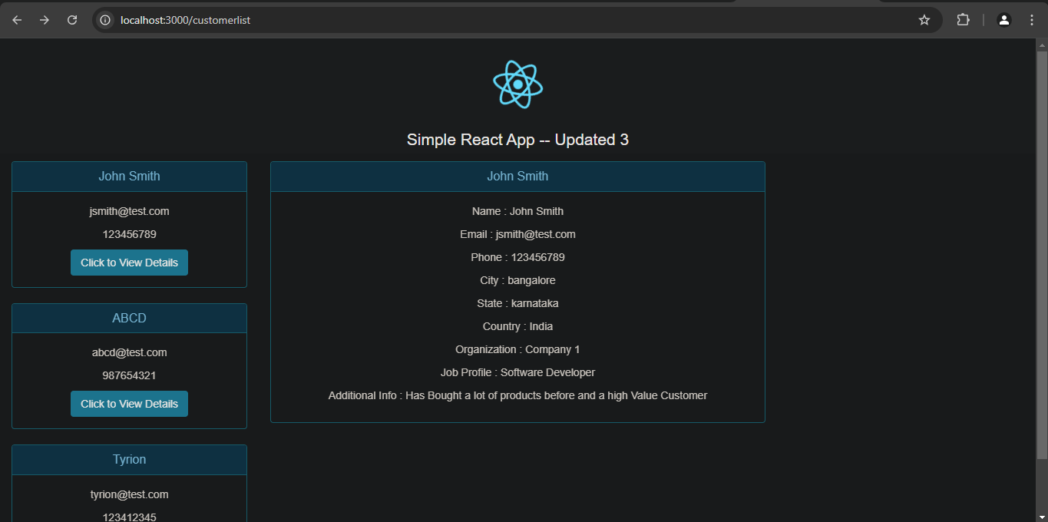

1. Start another docker container with latest 'nginx' image.

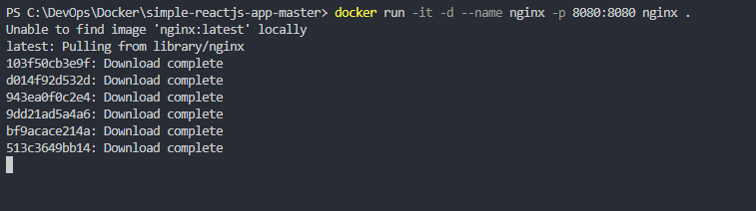

-> Open port: <http://localhost:8080/>

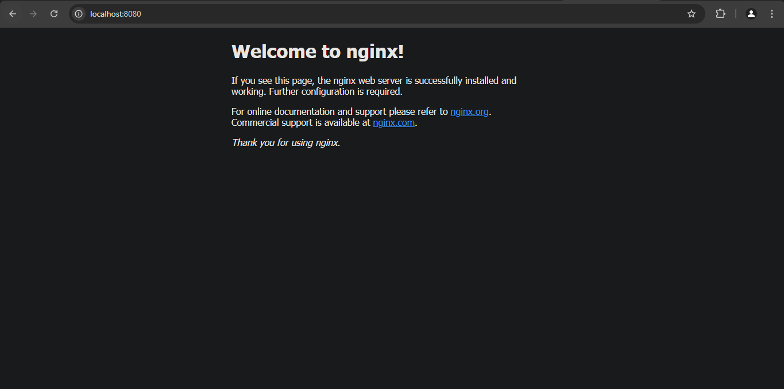

1. Go inside the application container, inside its terminal, and try to access/ping the nginx container to check the connectivity

-> Go instide the react-webapp container

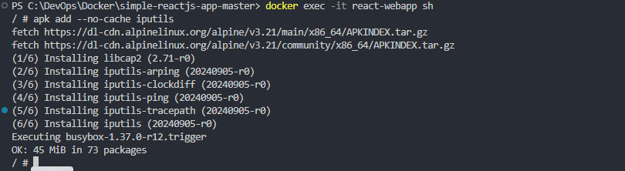

-> Try to ping nginx container.

-> This will give error as by default containers cannot communicate using names

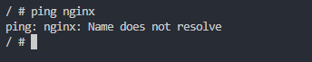

-> We can try to access using ip of the nginx container

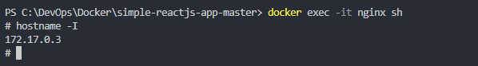

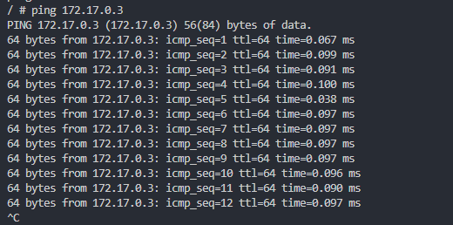

-> Or we connect both the container to a custom network

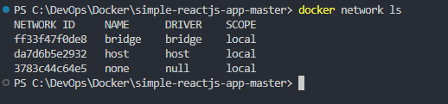

-> Create new network *mynet*



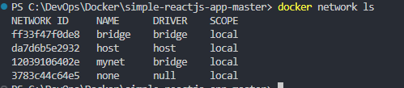

-> Connect both the containers to *mynet*





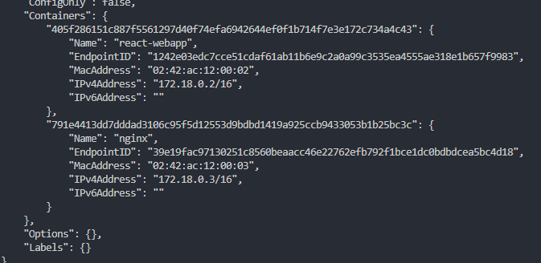

-> Now we wil be able to ping the *nginx* container by name

